Christian Education Events & Announcements August 28, 2023

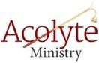
Acolyte Sign-up:
We invite and encourage ALL youth to sign up to acolyte. This ministry is a fun privilege, that our youth get to engage in every Sunday! If your youth would like to acolyte, please
sign up outside the office. Pastor Levi will assist younger children if they’d like to have a turn.

Rally Sunday:
We are inviting all church families to join us for Rally Sunday. A kick-off to the new Sunday School year! We are planning a free-will donation, hot dog meal. Learn who your Sunday School teacher will be, enjoy some games and see if you have what it takes to dump Pastor Levi into the dunk tank!!
September 10, 2023 immediately following 9 am service.

Sunday School Teachers:
We are taking a co-teaching approach to Sunday School this year. We are looking for volunteers to help co-teach our youth. If you or your older youth are willing to help co-teach or be a “fill-in”
teacher as needed, please connect with Jill in the church office or reach out to one of the members of the Board of Youth and Education. Weekly lesson plans and supplies will be prepared ahead of time so no prep work or planning would be required by you.

Backpack Blessing:
Bring your backpack to church on Sunday, September 10, 2023 and have it blessed for the upcoming school year.

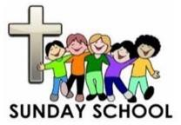
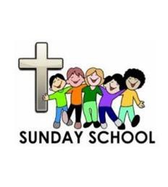
Upcoming Sunday School Schedule:
Sunday School begins September 17, 2023, immediately following 9 am service. Who: All youth pre-school – 6th grade!!

New Orleans Youth Gathering:
We are looking at putting together a trip for high school students (grades 9-12) to attend the New Orleans, Louisiana, ELCA Youth Gathering July 16, 2024 –
July 20, 2024. Informational meeting for the 2024 ELCA Youth Gathering in New Orleans will be held on Wednesday, September 6th at 7:00p.m., located at Bethel
Lutheran Church, Porter, MN. A Pastor from Wabasso will be presenting the information. Fundraising will be set up to help defray costs. We are hoping to offer this trip every three years. If your high schooler would like to consider this, please attend the meeting.

Usher Ministry
We are looking for families to help usher during Sunday Services. Some things ushers are responsible for are: handing out bulletins as church starts, collecting offering and excusing the congregation by rows for communion. There will be a sign-up sheet posted outside the office. What a great way for YOUR family to be involved. Please consider helping out with this ministry.

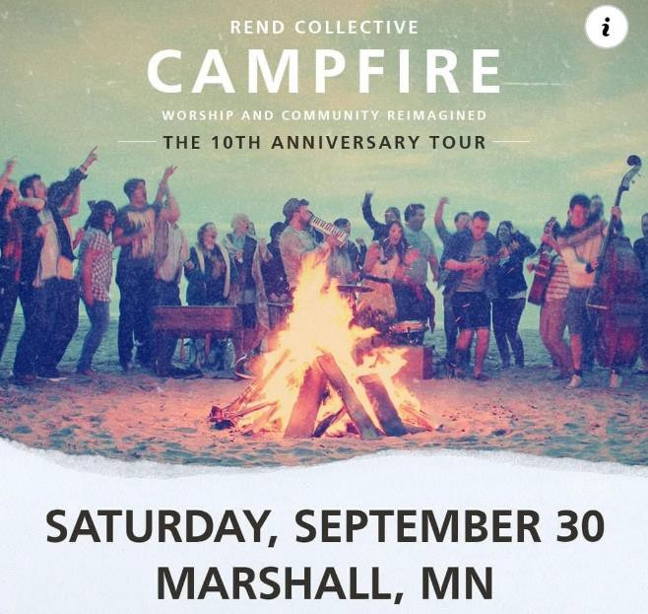
Rend Collective Campfire
Campfire 10th Anniversary Tour in the R/A Facility at SMSU, Saturday, September 30, 2023 at 7:00 PM. Rend Collective is a Northern Irish Christian folk rock worship band originating from Bangor, Northern Ireland. General admission is $25/person. More information can be found on the Rend Collective Facebook page or at: rendcollective.com

Board of Youth and Education:
oslcanbymn@gmail.com Kathy Becker: 507-822-1669
Jill Winters: 507-829-6766
Amanda Appel: 507-530-3999
Pam Hanson: 605-251-1422 Josie Frank:
Amanda Anderson: 320-296-5672

Junior High Youth Gathering – Save The Date
Junior High Youth Gathering to take place in Willmar, MN. November 17-19, 2023. Registration opens early September. More information will be provided as soon as it becomes available. If you are interested in chaperoning for this event, please reach out to Jill in the office.

